Session 2025-2026
Mission: To establish learning ambience for ushering in computer engineering professionals in core and
multidisciplinary area by developing Problem-solving skills through emerging technologies.
Vision: To be a well-known centre for pursuing computer
education through innovative pedagogy, value-based education and industry collaboration
Program Educational Objectives of the program (PEO): (broad statements that describe the professional and career accomplishments)
PEO1 | Preparation | P: Preparation | Pep-CL abbreviation pronounce as Pep-si-lL easy to recall
PEO2 | Core Competence | E: Environment (Learning Environment)
PEO3 | Breadth | P: Professionalism
PEO4 | Professionalism | C: Core Competence
PEO5 | Learning Environment | L: Breadth (Learning in diverse areas)

Program Outcomes (PO): (statements that describe what a student should be able to do and know by the end of a program)

Keywords of POs:
Engineering knowledge, Problem analysis, Design/development of solutions, Conduct Investigations of Complex Problems, Engineering Tool Usage, The Engineer and The World, Ethics, Individual and Collaborative Team work, Communication, Project Management and Finance, Life-Long Learning
PSO Keywords: Cutting edge technologies, Research

“I am an engineer, and I know how to apply engineering knowledge to investigate, analyse and design solutions to complex problems using tools for entire world following all ethics in a collaborative way with proper management skills throughout my life.” to contribute to the development of cutting-edge technologies and Research.

Integrity: I will adhere to the Laboratory Code of Conduct and ethics in its entirety.

Name and Signature of Student and Date
(Signature and Date in Handwritten)
Disha Angalwar
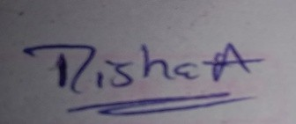

Session | 2025-26 (EVEN) | Course Name | JAVA FSD Lab
Semester | 4 | Course Code | 23ADS1407
Roll No | 4 | Name of Student | Disha Angalwar

Practical Number | 06
Course Outcome | Implement Java programs implementing control structures, searching (Linear Search), sorting (Bubble Sort), and object-oriented programming concepts such as inheritance and polymorphism.
Aim | WAP to demonstrate polymorphism  in java.
Problem Definition | PROBLEM STTMT 3. Write a Java program to demonstrate using method overriding.  Create a superclass named Shape that contains a method draw() which prints "drawing...".Create three subclasses:  - Rectangle  - Circle  - Triangle
Theory  (100 words) | Method overriding is an important concept of Object-Oriented Programming (OOP) that allows a subclass to provide a specific implementation of a method already defined in its superclass. It supports runtime polymorphism, where the method call is resolved at runtime based on the object type. In this practical, a superclass Shape defines a method draw(), and subclasses like Rectangle, Circle, and Triangle override this method with their own implementations. This demonstrates how the same method name can perform different actions. Method overriding improves flexibility, reusability, and helps achieve dynamic behavior in Java programs.

Procedure and Execution | Algorithm:  - Start the program.  - Create a superclass Shape with a method draw().  - Create subclasses Rectangle, Circle, and Triangle.  - Override the draw() method in each subclass.  - Create objects of each subclass.  - Call the draw() method using each object.  - Display the respective output for each shape.  - Ensure method overriding works correctly.  9) Stop the program.
(100 Words)
Code:
class Shape {
void draw() {
System.out.println("drawing...");
}
}

class Rectangle extends Shape {
void draw() {
System.out.println("Drawing Rectangle");
}
}

class Circle extends Shape {
void draw() {
System.out.println("Drawing Circle");
}
}

class Triangle extends Shape {
void draw() {
System.out.println("Drawing Triangle");
}
}

public class MethodOverridingDemo {
public static void main(String[] args) {
Shape s;

s = new Rectangle();
s.draw();

s = new Circle();
s.draw();

s = new Triangle();
s.draw();
}
}

 | Output:
 | 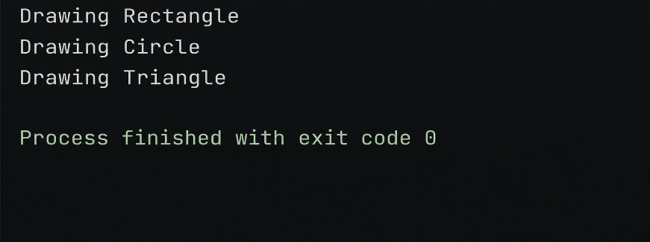
Output Analysis | The program successfully demonstrates method overriding.  Each subclass (Rectangle, Circle, Triangle) provides its own implementation of the draw() method.  The output changes based on the object type at runtime, showing runtime polymorphism.  It confirms that the same method name can perform different actions.  The program executes correctly with no errors, indicating proper implementation.

Link of student Github profile where  lab assignment has been uploaded | https://github.com/dishaangalwar84/JavaFSD
Conclusion | - In this practical, we learned the concept of method overriding in Java.  - We understood how a subclass can redefine a method of its superclass.  - We observed runtime polymorphism, where the method call depends on the object type.  - We learned how the same method (draw()) can produce different outputs for different classes.  - Overall, this helped us understand flexibility and dynamic behavior in OOP.
Plag Report (Similarity index < 12%) | 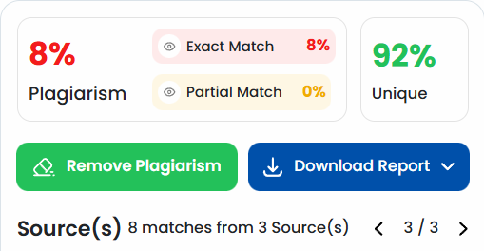
Date | 10 Mar 2026
Faculty signed observation page.

